Hi David,

I sent to link on github.This example which I downloaded from network,because I think it can use for wordpress if I replace some code,but it create one 'tidy.css' file.

I don't know how to create multi unused css file for each css file.

I want to create the project which you made but I don't know how to begin.Grunt is so new for me.

For more clearly,I add some images for themes wordpress which I want to use Grunt

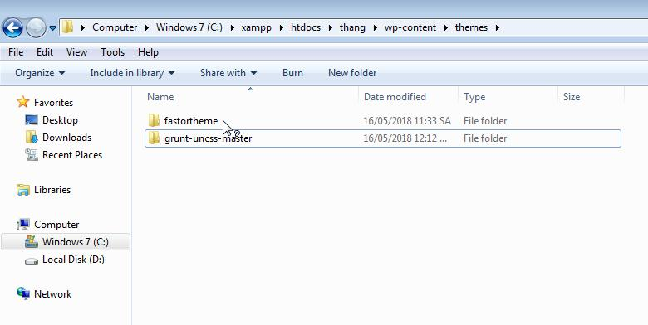

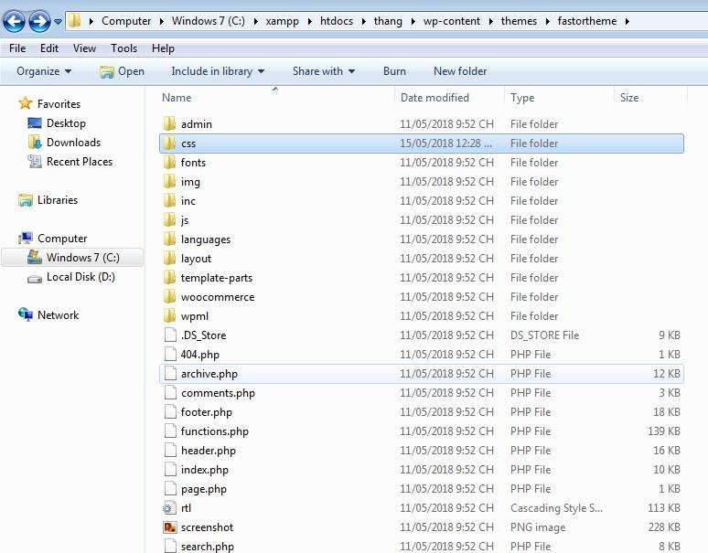

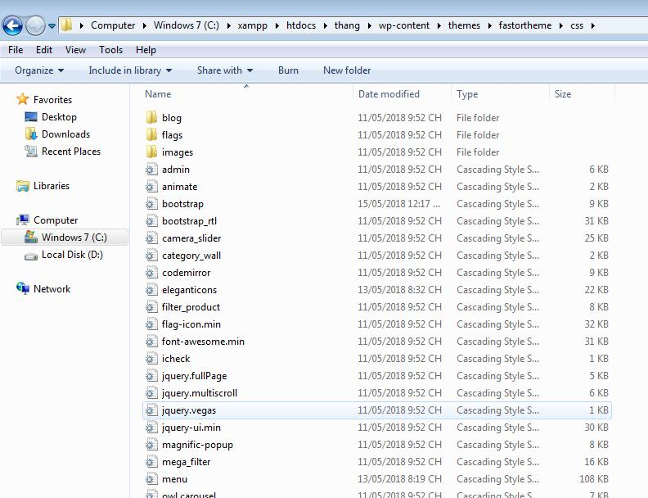

Sorry for some errors English,I'm come from non English language country.

Thank you very much,David.